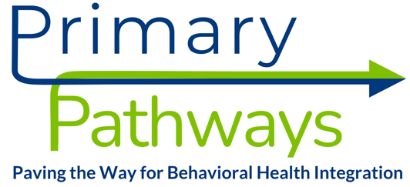

Pediatric Practice Interest Form Primary Pathways Payment Model Pilot Please email your completed interest form to zelda@vahealthinnovation.org to begin the application process.

Practice Information
Group Name: Click to enter text.  Practice Name: Click to enter text. | Date: Click to enter a date.
TIN: Click to enter text.
Point of Contact Name: Click to enter text.
Email Address: Click to enter text.

How many practices or sites does your organization support? Click to enter text.
Where is your practice located? Click to enter text.

Does your organization serve Medicaid patients? Click to enter text.
Note the Primary Pathways payment model is currently being piloted with Medicaid MCOs Anthem and Sentara. If your
organization does not serve this population, you will not be eligible to participate.

Anticipated Tier Information
Do you employ a care manager? Click to enter text.
Do you employ a behavioral health provider? Click to enter text.
Visit https://www.vahealthinnovation.org/primary-pathways for Tier requirements.

